DH <3263>; <Security Lending>
  - Business Requirements Document

US PMO Template

Document Version: | 0.1

Update this value with the number of each new version as reflected in Revision History.
Initial version number is always 0.1.

Originated by:

Please consult the document classification policy to confirm the proper classification in the footer. All Commercial BRDs should be classified as “Confidential”

Approvers
This document has been approved by the Business Sponsor, or delegate, as the official Business Requirements Document for the project. Following approval of this document, changes will be governed by the project’s change control process, including impact analysis, appropriate reviews and reapprovals.

Business Line | Colleague Name | Colleague Title | Approval email  attachment | Date (MM/DD/YYYY)
Treasury | Ted Fernandez | Project Sponsor |  | 04/29/2026

Contributors & Reviewers
This section is to identify parties who contributed to the business requirements or have a vested interest in the project. Examples include subject matter experts, operations teams, downstream customer facing application product owners, and technology partners. Note, you can use the list of individuals from the Gate 3 Stakeholder Alignment meeting as a starting point for identifying your key constituents. Reach out to those individuals to obtain points of contact for your requirements gathering sessions.
https://shusa.sharepoint.com/sites/pmo/Pages/OpsReadiness.aspx

Colleague Name | Colleague Title | Business Line
Marcus Medeiros | Project Manager | Treasury

Peer Reviewers

The following Peer Review team members acknowledge the completion of the analysis and discussion of the BRD with the business analyst, and attendance in the Peer Review meeting.
Not applicable. BSI do not have a BA role to do this additional check as communicated already to SHUSA

COE Peer Reviewer | Peer Reviewer 1 | Peer Reviewer 2 | Peer Review Meeting Date
 | <Name> | <Name> | <Date>

Revision History

Date | Version Number | Document Changes
02/27/2026 | 0.1 | Initial Draft
04/12/2026 | 0.2 | 2 new requirements added

Table of Contents
1 Project Summary 6
1.1 Project Background and Overview 6
1.2 Assumptions/Dependencies/Constraints 6
1.2.1 Requirements Assumptions & Dependencies 6
1.2.2 Project Constraints 6
1.3 Out of Scope 7
1.4 Business/Customer/Channel Impact 8
2 Current and Future States 8
2.1. Current State 8
2.2 Future State 9
3 Requirements 10
3.1 Business Requirements 10
4 Non-Functional Requirements 17
4.1 Security 17
4.2 Data Governance 17
4.3 Auditability 17
4.4 End User Ease of Usability 17
4.5 Performance Efficiency 17
4.6 Scalability 18
4.7 Reliability 18
4.8 Business User Maintainability 18
4.9 Backup and Recovery 18
4.10 Availability 19

Project Summary

Project Background and Overview
This project aims to create a new revenue stream for BSI Miami with the introduction of the Security Lending business. This new service will allow BSI to lend its clients’ securities held on custody at JP Morgan, in accordance with the current regulation, to pre-approved borrowers, supporting BSI to manage its liquidity needs and enhancing its returns.

Assumptions/Dependencies/Constraints

Requirements Assumptions & Dependencies
                - The requirements in this BRD have the following assumptions and dependencies:
- Assumption or Dependency? [A #or D#] | - Related Requirement Number | - Note the Assumption or Dependency
- NA | - NA | - NA

Project Constraints
                - The project has the following constraints:
- Number [C#] | - Constraint
- NA | - NA

Out of Scope

The following components are out of scope of this BRD:

- Number [OOS #] | - Out of Scope Item
- 1 | - Term Loans
- 2 | - Cash or Equity as collateral
- 3 | - Proprietary Lending

1.4 Business/Customer/Channel Impact

Business/Customer/Channel | Impact Description
ATM | NA
Branch | NA
Call Center | NA
Internet - Santander.com | NA
Intranet | NA
Mail/email | NA
Mobile Banking (personal, business, commercial) | NA
New or substantially altered Product | No
Online Banking (personal, business, commercial) | NA
Risk and Control Self – Assessment (RCSA) Review | No need to be updated – already completed in phase 1
Santander Corporate Offices/Back end | NA
<Other (please specify)> | <N/A>

Current and Future States

Current State
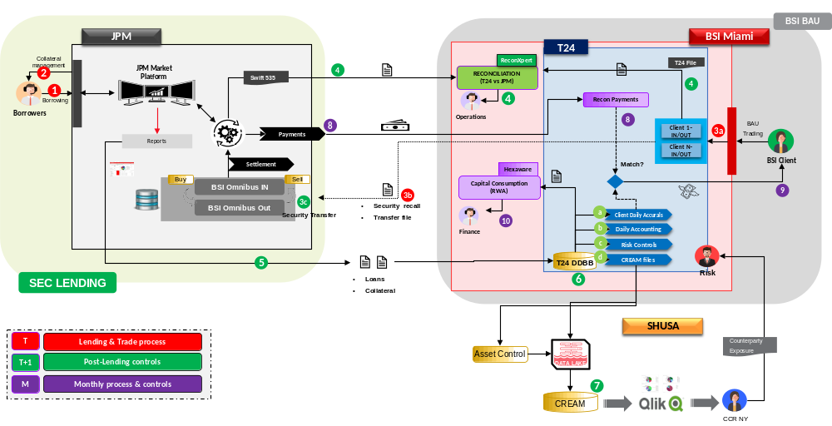

Future State
No significant change as phase 2 includes only minor improvements/reporting requirements.

Requirements

Business Requirements

RQT ID | Description (Requirement Type) | Type | Owner | Comments
1 | - Update Annual Fiscal Report | Functional | Treasury | Mandatory
2 | - Security Lending Dashboard | Functional | Business Analytics | Mandatory
3 | - Accurals automatic recalculation | Functional | Treasury, Finance | Mandatory
4 | - Accounting categories update | Data | Finance | Mandatory
5 | - Improve existing Notional control | Functional | Treasury, Risk | Mandatory

Annual Fiscal Report

5.1.1 Functional Background.
The fiscal report is not a regulatory report but is can be provided to clients at any tie upong request. Since it is not regulatory, it was agreed that Treasury will take ownership of its update as the sponsor for Security Lending within the bank.
A sample report can be found below:

5.1.2 Requirement definition:

- New section must be created for “Securities Lending”
- The “Securities Lending” section should be placed before the “Fees” section
- The “Securities Lending” section should have a table with the following colunms:
  - Payment Date
  - Payment Type: "Fee Income" by default
  - Description: "Security Lending Income - Month name" by default
  - Currency: “USD”
  - Amount

Hence, this section will display 12 payments per year.

Management Dashboard

5.2.1 Functional Background.
Senior Management requested a new dashboard to be created in Tableau to monitor the sec lending activity.

5.2.2 Requirement definition:

For IT T24,

- The “Loan Position report” received from JP Morgan should be make available for the Tableau team. The report can be sent to the existing folder shared with Tableau as indicated below:

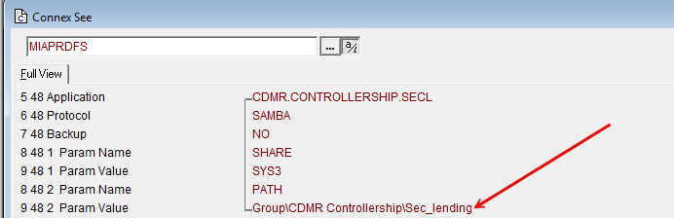

- In the files shared with MEDEA, we need to aggregate the depository field to each client position (to calculate the total Assets Available for lending). We should add this information to field 78.

For Business Inteligence,

Using the data contained in the “Loan Position report” and the positions taken from MEDEA, the following rules must be applied to design the dashboard:

- Assets available for lending: Using the depository field from MEDEA, we can calculate the total Assets Available for lending by filtering the “IN depository” and applying the 70% threshold;
- Lent Balances: Loan Position report (column P – Loan Market Value);
- Utilization rate (%): Lent balances / Assets Available for Lending (both above);
  - Average lending spread (bps) Source = T24 (Loan position report)
    - Gross Rate (including JPM, BSI + Clients) {(NET.EARNINGS (Column AA) / Aggregate Lent Balances)*360}
      - BSI Gross Rate (Includes BSI + Clients) Gross Rate (above) x 75%
      - BSI Net Rate (Incudes BSI Bank Only) Gross Rate (above) x 56.25%
      - BSI Clients Rate (includes BSI Clients only) Gross Rate (above) x 18.75%

*These rates are represented in annualized terms

- Gross and net lending revenue
  - Source = T24 “Loan position” report
    - Gross Revenue (including JPM, BSI + Clients) Aggregate NET.EARNING (Column AA)
    - BSI Gross Revenue (Includes BSI + Clients) Aggregate CLIENT.EARNINGS (Column X)
      - BSI Net Revenue (Incudes BSI Bank Only) BSI Gross Revenue (above) x 75%
      - BSI Client Revenue (Includes BSI clients only) BSI Gross Revenue (above) x 25% = 7.37

Accurals Recalculation

5.3.1 Functional Background.
During the project’s implementation (phase 1), a routine was created to automatically reconcile the payment received from JP Morgan and the daily accurals accumulated in T24. Small differences are expected, so a rule was implemented to accept a difference smaller than 1,000 USD. However, if the difference is bigger, BSI Finance should call that out and inform BSI Treasury. Thereafter, BSI Treasury would reach out to JP Morgan to understand the differences. If BSI Treasury approves the payment, the accurals must be re-calculated to match the amount received before the payment can be executed by BSI Operations.

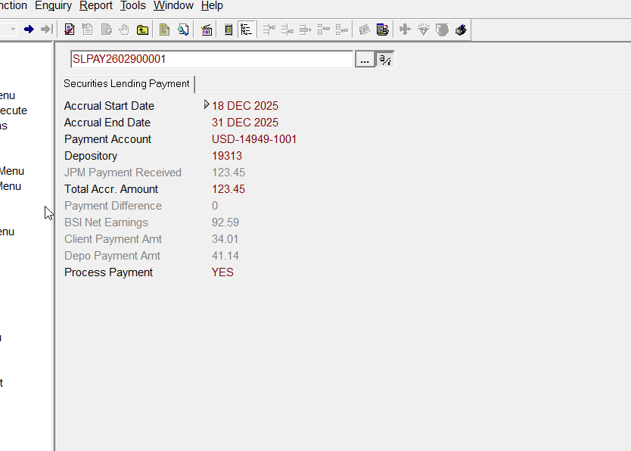

5.3.2 Requirement definition:
A simple “rule of 3” should be applied to recalculate the accurals. This simple logic would keep each client receiving the same % of the total amount paid to clients. A more complex logic would require BSI to investigate the differences in the accurals security by security and day by day, which is not feasible.

For example:

- Let´s imagine that the total accured in T24 was USD 100,000.
- However, JP Morgan pays us 110,000. The reconciliation would spot a difference of 10,000 and trigger an alert. If BSI Treasury approves the new amount, then:
  - If client A was going to get 50,000, he now gets 55,000
  - If client B was going to get 20,000, he now gets 22,000
  - If client C was going to get 30,000, he now gets 33,000

New accounting categories:

5.4.1 Functional Background.
During the project’s F&F phase, a new accounting recommendation was given to BSI and the sec lending payment will not be categorized as fee income instead of interest payment. This required new accounts to be opened and new categories to be used.

5.4.2 Requirement definition:
The file attached shows the new accounting map:



Improve T24 Accurals Report

T24 – List Client Accruals query:
- Please include ISIN before security master column.

- Set up daily and monthly accrual reports to be automatically stored in the following folders (if possible):
- Daily Accruals Report: K:\Apps\Globus_RPTARC\data\TREASURY/SecLendingAccruals
- To be automatically stored every business morning for the previous position date(s)
  - Weekends and holidays should be stored as well
  - Make sure ISIN is on report please (before Security Master)

- Monthly Accruals Report : K:\Apps\Globus_RPTARC\data\TREASURY/SecLendingAccruals
- To be automatically stored the first business day of the month, for all position dates for the previous month
  - Weekends and holidays should be stored as well
  - Make sure ISIN on report please (before Security Master)

- Once the above reports start being auto generated, send us a one-time file for all previous position dates?
- This is so we can successfully back test and validate all previous data (Inv rates, accruals, etc.).

Daily T24 control – Notional Limit

5.5.1 Functional Background.
During the project’s first phase, a daily control was implemented in T24 to ensure that we are not lending more than USD 250MM to each counterparty. This control uses the Loan Position Report received from JP Morgan, checks all the loans to each counterparty and ensure that the sums of the loan notionals are never above USD 250 MM per counterparty.

5.5.2 Requirement definition:
The business wants to increase the size of the loans to some counterparties to allow USD 5OOMM for 9 strategic borrowers. Since the business can decide to increase/decrease the size of loans again in the future, ideally the solution should allows us to have a “table” in T24 that would allos to define the limits per counterparty as a parameter that we can easily change in the future.

Right now, those are the counterparties that will havea limit of 500MM:

Code | Borrowers
PSFXG | Citigroup Global Markets Limited
GSLIG | Goldman Sachs International
JPMLG | J.P. Morgan Securities PLC
MLUKG | Merrill Lynch International
MORSG | Morgan Stanley & Co. International PL
NOMUG | Nomura International PLC
MIDLG | HSBC Bank PLC
UBSAG | UBS AG, GR
BARLG | Barclays PLC

All other counterparties will remain with the current limit of USD 250MM.

Nonetheless, as pointed out above, the idea is to be flexible and have a solution that would allow the business to change the limits per counterparty without the need of new developments in the future.

Non-Functional Requirements
Non-Functional Requirements specify criteria that can be used to evaluate the operation of a system rather than specific behaviors.
- If any of the following tables are BAU, enter “N/A” for the Req # cell, and “BAU” for the Requirement cell.
- Remove any blank rows.

Security
Describe security requirements related to who shall have access to the system, when and at what level.
Req # | Requirement
1 | Appian DAST
2 | Appian Approval Check
3 | JP Morgan Securities DAST
4 | JP Morgan Securities DAST
5 | JP Morgan Securities PENTEST
6 | JP Morgan Securities WAF Configuration Check

Data Governance
Describe data security and privacy levels and regulations, data conversion and cleansing requirements, as well as retention requirements.
Req # | Requirement
NA | NA

Auditability
Define the business elements and data fields that the business intends to audit including information needed in the audit file.
Req # | Requirement
NA | NA

End User Ease of Usability
Describe quantitatively the level of usability required. Also refer to any usability standards and guidelines that must be adhered to.

Req # | Requirement
NA | NA

Performance Efficiency
Describe the response time. That is, the maximum allowable wait time from the moment the user submits a request until the system returns a response.
Describe the stress the system can tolerate such as the degree of simultaneous activity that the system must be able to support.

Req # | Requirement
NA | NA

Scalability
Describe the maximum volume (e.g., the number of accounts, users, tellers) that the system must be able to support. Describe anticipated increase in users, workload, transactions or events.

Req # | Requirement
NA | NA

Reliability
Describe the ability of the solution or component to perform its functions under stated conditions for a specified period of time (fault tolerance).

Req # | Requirement
NA | NA

Business User Maintainability
Describe the ease with which a solution or component can be modified to correct defects, improve performance or other attributes, or adapt to changes. Include potential alterations after launch and frequency of modifications or business rules. Will the system need to be altered after launch? – consider configurations for end user post implementation.

Req # | Requirement
NA | NA

Backup and Recovery
Describe the data and system backup and recovery required, as well as impact due to data loss.
This section will also be used to define Disaster Recovery (DR) requirements, NF 4.9.1 – NF 4.9.3. Select an RTO & RPO range from the options below. RTO refers to the maximum amount of time to recover from an outage. RPO refers to the maximum tolerable amount of data loss measured in time. The implemented DR solution must be able to achieve the documented recovery requirements. RTO/RPO selections align with the Santander US Business Impact Analysis (BIA) process, and are to be reviewed with the Business Sponsor and IT. For 3rd party hosted software, this information should be found in the contract.

Req # | Requirement
NA | NA

4.10 Availability
Describe when the solution is operable and accessible (e.g., allowable downtime, maintenance allowances, % of time the solution is available to users).
Req # | Requirement
NA | NA

Table 1. Unavailability timeframes allowed for each Availability requirement
Availability of…  Means… | 99.95% | 99.90% | 99.50% | 98.00% | 95.00%
Daily downtime of | 43.2s | 1m 26.4s | 7m 12.0s | 28m 48.0s | 1h 12m 0.0s
Weekly downtime of | 5m 2.4s | 10m 4.8s | 50m 24.0s | 3h 21m 36.0s | 8h 24m 0.0s
Monthly downtime of | 21m 54.9s | 43m 49.7s | 3h 39m 8.7s | 14h 36m 34.9s | 1d 12h 31m 27.3s
Yearly downtime of | 4h 22m 58.5s | 8h 45m 57.0s | 1d 19h 49m 44.8s | 7d 7h 18m 59.0s | 18d 6h 17m 27.6s

